Başkent University

Department of Electrical and Electronics Engineering

EEM 214 Electronics I

Experiment 7

MOSFET Transistor Basics
Aim:

The aim of this lab is to familiarize the student with the basic regions of operation of a MOSFET transistor.

Theory:

The MOSFET device is a four terminal device with connections for the drain, gate, source, and body as shown in the symbol in Fig.1. However, a more common symbol used to identify the MOSFET is shown in Fig.2 and is what will be used in this experiment. The MOSFET devices used in this lab have the body internally connected to the source such that the body terminal is not externally accessible. Shown in these figures are N-channel MOSFETs.

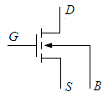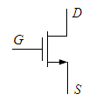
figure_1: MOSFET 4-Terminal Symbol figure_2: MOSFET 3-Terminal Symbol

To study the MOSFET we connect two external voltage sources to the device as shown in Fig.3. These provide a drain-source voltage V_{DS} and a gate-source voltage V_{GS}.

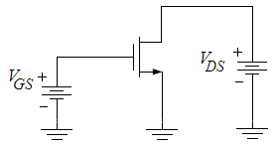
figure_3: MOSFET with V_{GS} and V_{DS} connected

The voltage V_{DS} may cause a drain-source current I_{DS} to flow provided a path exists from the drain to the source inside the device. This internal current path can be controlled by the gate-source voltage V_{GS}. For a sufficiently high V_{GS}, an internal current path, called the channel, is established between the drain and the source. The higher the V_{GS} value the easier it is to flow for the drain-source current I_{DS}. Note that the only DC current in the MOSFET is I_{DS} since the gate is internally insulated from the channel.

By operating the MOSFET in particular bias regions, based on the V_{GS}, V_{DS}, and I_{DS} values, it can be used to perform a variety of functions. The two regions that the MOSFET device can operate in are the ohmic(linear) and saturation(active) regions. Both of these regions will be explored in this experiment through the exploration of a few of the MOSFET device implementations. These regions can be graphically represented. Shown in Fig.4 is the MOSFET I_{DS} / V_{DS} curve for constant values of V_{GS}. Notice that, the ohmic region exists where V_{DS} is very small and the curve is nearly linear, hence another name for the region, the linear region. As V_{DS} increases, the curve begins to flatten. When V_{DS} is equal to the saturation voltage, V_{D(SAT)}, the device enters the saturation region. This voltage, V_{D(SAT)}, is determined by the voltage V_{GS} of the MOSFET along with a physical parameter of the MOSFET called the threshold voltage V_{T}.

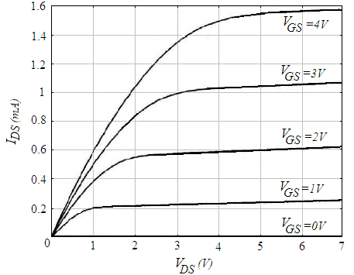
figure_4: Typical MOSFET I_{DS} / V_{DS} curve

For a MOSFET, V_{D(SAT)}=V_{GS}–V_{T}, and for V_{DS(SAT)}≥V_{D}≥0, the device is in the ohmic(linear) region of operation, and for V_{DS}≥V_{D(SAT)}≥0, the device is in the saturation region of operation.
The current flowing through the device in the ohmic(linear) region of operation is given by the following equation:

1) 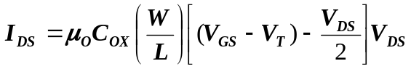

Given the V_{GS} and V_{DS} values as well as the physical MOSFET sizing W/L and the physical parameter μ_{o}C_{ox}, the current I_{DS} can be found for the ohmic(linear) region. The W/L parameter is the width of the device divided by its length and the fabrication process of the device determines the physical parameter μ_{o}C_{ox}. In this region of operation, the MOSFET acts as a voltage controlled resistor where the value of drain-source resistance can be found by taking the partial derivative of I_{DS} with respect to V_{DS} as shown below:

2)
The device can also be operated in the saturation region. This region is primarily used for amplification of an input signal. However, amplification will be studied in subsequent experiments, in this experiment we are limiting the discussion to DC bias conditions in the saturation region of operation. The current I_{DS} in the saturation region of operation can be found from the following equation (for simplicity, λ is assumed to be zero):

3) 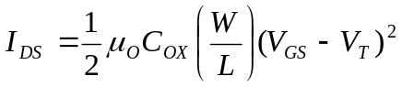

In this region, the device acts as a voltage-controlled current source, hence its use as an amplifier. The current source created is not ideal and is shunted by a small signal equivalent resistance referred to as r_{ds}. The small signal resistance r_{ds} will be studied in more detail later. For this experiment, the concern is with find the current I_{DS} based on the values of V_{GS} and V_{DS}.

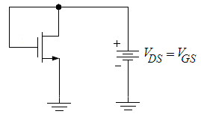
figure_5: Diode-Connected MOSFET

In the saturation region, the MOSFET can be connected to act similar to a diode. The MOSFET is commonly called diode-connected when configured as in Fig.5. The voltage across the device can be set to provide a reference voltage that may be needed in a particular application. The equation to find the voltage across the device can be found by solving Equation3 for V_{GS} since the V_{GS} of the device is equal to V_{DS}. This equation for V_{MOSDIODE} is shown below:

4) 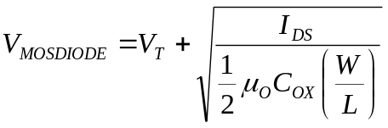

By diode-connecting the device, the saturation region is virtually guaranteed. Knowing the I_{DS}, W/L, and μ_{o}C_{ox} the voltage V_{MOSDIODE} can be found.

Preliminary Work:

Review the sections 4.10 from the Text Book.

In laboratory you will use the MOSFET Chip CD4007. The NMOS has μ_{o}C_{ox}= 166.67μA/V², W/L=3 and V_{T} = 1.45V. Assume V_{A} =1/λ =100V. The Pin Diagram of the CD4007 Chip is in Fig.6.

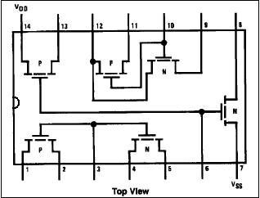
Reference:

[1] The values given for the μ_{o}C_{ox}(W/L) and V_{T} found using the measured data on the CD4007 chip were provided courtesy of Dr. David M. Binkley, Associate Professor at the University of North Carolina at Charlotte and Clark Hopper M.S, R.A. and Harold Hearne M.S., R. A. both also at the University of North Carolina at Charlotte.

figure6

- For the MOSFET shown in Fig.3, solve for the drain-source current I_{DS}, indicate the region of operation, and, if necessary, solve for the drain-source resistance r_{ohmic} for the following conditions.

  - V_{GS} = 3V ; V_{DS} = 0.5V
  - V_{GS} = 5V ; V_{DS} = 0.5V
  - V_{GS} = 2V ; V_{DS} = 3V.

- Using the following peusedocode, plot the mosfet I_{DS}-V_{DS} curve in Matlab for the V_{GS} values increments by 0.5 volt from 0 to 4 overlaid on the same graph like in figure_4. Clearly indicate the operation regions. Vary the V_{DS} from 0V to +5V by 0.01 increments.

for λ=0
if V_{GS}<V_{T} mosfet operate in cut off region I_{D}=0
if V_{GS}≥V_{T} mosfet operate in active region
if V_{DS}≤V_{GS}-V_{T} mosfet in linear(ohmic) region
I_{D}=μ_{ox}C_{ox} (W/L)(V_{GS}-V_{T}-V_{DS}/2)V_{DS}
if V_{DS}>V_{GS}-V_{T} mosfet in saturation region
I_{D}=(1/2)μ_{ox}C_{ox} (W/L)(V_{GS}-V_{T})²

- Desiring a MOSFET resistor with a resistance of 100kΩ, find the value of V_{GS} needed to create this resistor given V_{DS}=0V.

- For the MOSFET shown in Fig.7, solve for V_{DS}=V_{MOSDIODE} and the value of R. (Hint: Write a KCL equation at the drain of the MOSFET and use Equations 3 and 4.)

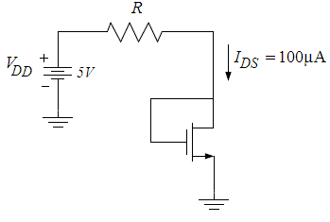
figure_7

- Read the experimental Work.

Experimental Work:

You will be using CD4007 MOSFET array as in this experiment. This array contains three NMOS and three PMOS transistors as shown in Fig.6. Again, the key point to remember is that the bulk (or substrates) of all NMOS transistors are connected to the VSS (pin 7) and all PMOS substrates are connected to VDD (pin 14). When using this array pin 7 should be connected to the most negative supply voltage or to the source of the transistor. Pin 14 is the substrate of the PMOS and must be connected to the most positive supply voltage in the circuit!
CD4007 MOSFET array should not be connected to circuits with the power on because high transient voltages may cause permanent damage. Therefore, do not apply input signals until you have connected PIN 7 and 14; otherwise, serious damage to the device could result.
It should be mentioned that the transistor characteristics of CD4007 could vary considerably from chip to chip. The transistors may come from a different batch, what can explain why the threshold voltage, the transconductance parameter and the output resistance is different from the one used in the hand calculations and Spice simulation.
Precaution: MOSFET transistors are very susceptible to breakdown due to electrostatic discharge. It is recommended that you always ground yourself before picking up the MOSFET chip. Do no touch any of the pins of the chip.

Note: Use jumper wires as possible as short on your board to connect the pins of the transistors.

Before constructing the circuit,

- Verify the values of the resistors that you are going to use by measuring their resistances with a multimeter. Make sure that all resistors are within 2% of their marked values. This will assure that your current measurements are accurate

- Prepare the power supply for V_{GS} to ensure a DC voltage of +4V (before connecting to the circuit. Prepare the other power supply for V_{DS} to ensure a DC voltage of 0V (before connecting to the circuit.

***Note: Always turn on the DC power supply before applying the AC signal. Always turn off the AC signal before turning off the DC power supply.

- a. Observe the schematic shown in Fig.8. Notice that the numbers correspond to the pin connections on the CD4007 chip.

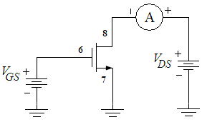
Figure_8: MOSFET Connections – MOSFET Curves

b. Connect the circuit as shown in Fig.8. Measure and record the drain current I_{DS} as V_{DS} is varied from 0V to +5V with V_{GS} = 4V. Take data points in 0.4V increments in order to have a sufficient number of values since these will be used to plot I_{DS}/V_{DS}.

c. Repeat the entire b. for V_{GS} = 3V, and V_{GS} = 2V.

 | I_{DS}
V_{DS} | V_{GS} = 2V | V_{GS} = 3V | V_{GS} = 4V
0.4V
0.8V
1.2V
1.4V
1.6V
1.8V
2V
2.2V
2.4V
2.6V
2.8V
3V
3.2V
3.4V
3.6V
3.8V
4V
4.2V
4.4V
4.6V
4.8V
5V

Using the data collected in Part.1 plot a family of curves(using Excel) for the three values of V_{GS} overlaid on the same graph. There should be one curve for each of the three values of V_{GS} (2V, 3V and 4V). Label each curve with the appropriate V_{GS} values and label approximately where the ohmic(linear) and saturation regions exist.

- With V_{DS} = 5V, determine the value of V_{GS} at which the current I_{DS} becomes negligible; assume for the purposes here that this means 5 μA. This value of V_{GS} is close to the threshold voltage, V_{T}, of the transistor for the MOSFET we are working with.

- a. Now observe the schematic shown in Fig.9. Again, note the pin connections to the CD4007 chip.

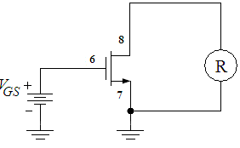
Figure_9: MOSFET Connections – MOSFET Curves

b. Connect the circuit as shown in Fig.9 with the ohmmeter across the drain and source. Vary V_{GS} and notice the change in resistance values. Measure and record the values of resistance for V_{GS} = 1.5V, 2V, 3V, 4V, and 5V.

V_{GS} | r_{ohmic}
1.5V
2V
3V
4V
5V

Using Equation 2 for the drain-source resistance r_{ohmic} for a MOSFET in the ohmic(linear) region of operation, find the resistance of the MOSFET for the following conditions given; 166.67μA/V², W/L=3, V_{T} = 1.45V and V_{DS}=0. Compare these with the values obtained in Part.3b. Complete a table of results compiling the measured and calculated values.

a) V_{GS} = 1.5V
b) V_{GS} = 2V
c) V_{GS} = 3V
d) V_{GS} = 4V
e) V_{GS} = 5V

- a. Prepare a DC current supply to a value of 100 μA to the circuit as shown in Fig.10. (Hint : Use the R value that you found on preliminary work part4). If necessary (if I_{DS} ≠ 100 μA) vary the DC current supply I_{DS}(by varying the Potentiometer) to 100 μA.
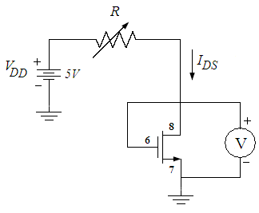
Figure_10: MOSFET Connections – Diode Connected MOSFET

b. Measure and record to voltage across the MOSFET and R_{POT} as shown Fig.10.

c. Now vary the DC current supply I_{DS}(by varying the Potentiometer) to the following values: 75μA, and 50μA. Measure and record the values of R_{POT} and V_{DS} for each condition.

R_{POT} | I_{DS} | V_{DS}
 | 100μA
 | 75μA
 | 50μA

Using Equation 4 for the voltage of a diode-connected MOSFET, calculate the voltages for the following conditions given. Compare these values with those obtained in Part.4. Complete a table of results compiling the measured and calculated values.

a) I_{DS}=100μA b) I_{DS}=75μA c) I_{DS}=50μA

- Why would it be necessary to create a resistor from a MOSFET? Name some advantages of doing so.

- Why would a MOSFET be connected like a diode? Would the voltage set by the MOSFET be helpful in circuit design?

Lab Instruments:  Breadboard  Multimeter  DC Power Supply | Components:  1 CD4007 Chip  100k POT

...............................………………………………………………………………..

Experiment Results

 | I_{DS}
V_{DS} | V_{GS} = 2V | V_{GS} = 3V | V_{GS} = 4V
0.4V
0.8V
1.2V
1.4V
1.6V
1.8V
2V
2.2V
2.4V
2.6V
2.8V
3V
3.2V
3.4V
3.6V
3.8V
4V
4.2V
4.4V
4.6V
4.8V
5V
V_{GS} | r_{ohmic}
1.5V
2V
3V
4V
5V

R_{POT} | I_{DS} | V_{DS}
 | 100μA
 | 75μA
 | 50μA

Student Name :

Number :

Signature…………….………

